Hands-On Lab
Lab Manual
Control source code by SVN

Contents
Control source code by SVN i
Lab: Control source code by SVN 3
Lab Objectives 3
Exercise 1 – Get code from the google code 3
1. Create an empty folder 3
2. In the Explorer, right-click on the space within folder $SDP_HOME, select menu item “SVN Checkout” 3
Exercise 2 – Create the folder for the team in SVN 5
1. Create a new folder “Team10” within E:\Studying\SDP\SourceCode 5
2. Upload the folder Team10 into the SVN Server by right-click on the space of folder “E:\Studying\SDP\SourceCode”. Then select menu item “SVN Commit”. 5
Exercise 3 – Create the project and upload into the Google Code 6
1. Create the web project skeleton 6
2. Commit the source code into the server 6
Exercise 4 – Modify code, add new code and commit into the server 8

Lab: Control source code by SVN
Estimated time to complete this lab: 45 minutes

Lab Objectives
The objective of this lab is to introduce you how to mange the source code in SVN of Google code by client tool TortoiseSVN (http://tortoisesvn.tigris.org).
- Upload the existed source code into the google code.
- Check-out the source code from the google code to the local.
- Commit/Update code.

Prerequisite:
- Installed TortoiseSVN (http://tortoisesvn.tigris.org)

Exercise 1 – Get code from the google code
This exercise helps you to get the document from the SVN Google Code “https://soft-dev.googlecode.com/svn/trunk/APT” into you local.
  - Create an empty folder
Example: E:\Studying\SDP (Call it as $SDP_HOME)
  - In the Explorer, right-click on the space within folder $SDP_HOME, select menu item “SVN Checkout”

Input URL of repository: https://soft-dev.googlecode.com/svn/trunk/APT. Then click on OK button.
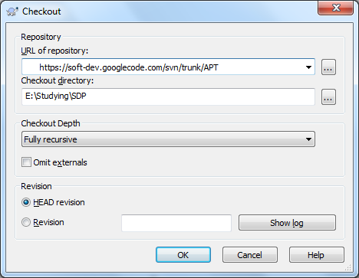
Now, you found the source folder of teams at “E:\Studying\SDP\SourceCode”. Next exercise will help you to create a new folder to practice the commit.

The check-out is performed once only. For next times, you want to get the latest code from the server, you select menu “SVN Update” after right-click on the space of folder “....\Team10”.

Exercise 2 – Create the folder for the team in SVN
  - Create a new folder “Team10” within E:\Studying\SDP\SourceCode
You found a icon before folder Team10. The sign means “this is a new folder which has not existed in the SVN server”.

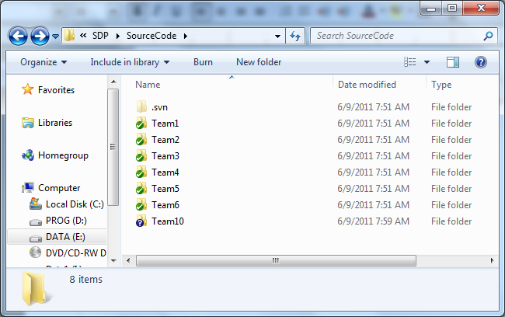

  - Upload the folder Team10 into the SVN Server by right-click on the space of folder “E:\Studying\SDP\SourceCode”. Then select menu item “SVN Commit”.
The dialog is displayed. Stick on the folder Team10, give the comments. Then click on OK button.

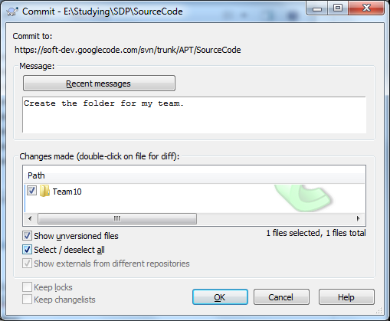
Give the comment here
Input the username (account name of gmail or the full email address) and password (refer lab “http://open-ones.googlecode.com/files/Subversion%20on%20Google%20Code.pdf”)

Exercise 3 – Create the project and upload into the Google Code
This exercise helps you to upload the current source code into the Google Code. To create a sample web application in Eclipse, refer the hands-on lab “Hands-on Lab_Develop a simple servlet applciation_v1.0.pdf” on the DVD (or download at “http://open-ones.googlecode.com/files/Hands-on%20Lab_Develop%20a%20simple%20servlet%20applciation_v1.0.pdf”.

  - Create the web project skeleton
Information for creating the project:
Project name: ProductWebTeam10
Project location: E:\Studying\SDP\SourceCode\Team10\ProductWebTeam10
Target Runtime: Apache Tomcat 7.0
Dynamic web module version: 2.5
Context root: product (all lower cases)
Now, you can commit this framework of the project for other members to develop at the same .
  - Commit the source code into the server
Before commit the source code into the server, please make clear there is no unnecessary files such as .class files. So you should delete the folder “build” before commit code into tthe server.
Right-click on the space of folder “E:\Studying\SDP\SourceCode\Team10”, select menu “SVN Commit”.
For carefully, you must stick of each file to make sure it will be managed version on the server. In this case, you can select all for quickly. Give the comment for this commit. Then click on OK button.
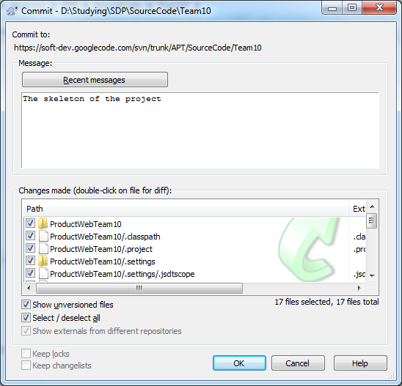
Now the latest version of source code is committed into the server.
Other team members can update code from the server into the local by Exercise 1.

Exercise 4 – Modify code, add new code and commit into the server
Please try it your-self to explore the SVN.

